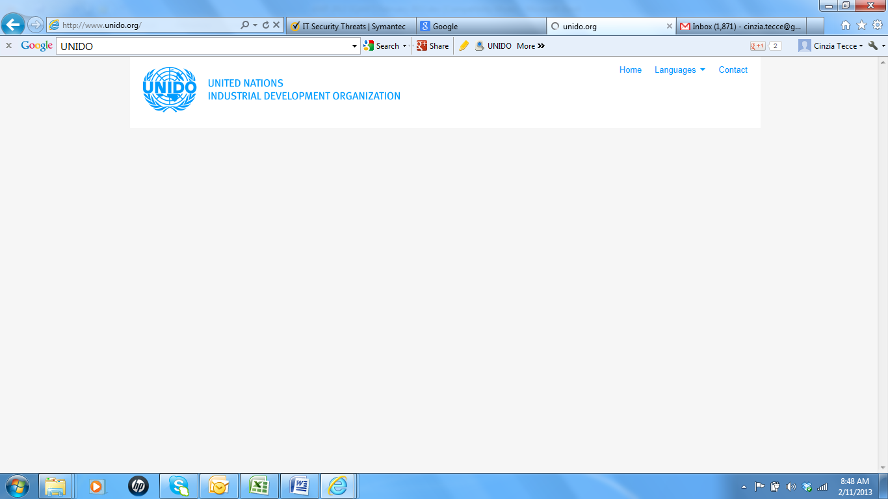
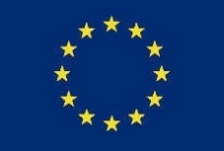

PROJECT

“Development of a robust Standardization, Quality Assurance, Accreditation and Metrology (SQAM) Infrastructure in Malawi”

UNDP Project ID 00083913

FIRST QUARTER PROGRESS REPORT
(1st January – 31st March 2017)

Malawi Bureau of Standards
(MBS)

April 2017

CONTENTS

ACRONYMS 3
Executive Summary 4
A. Situational Background/Context 9
B. Assessment of Project Results during the Reporting Period 10
C. Financial Status and Utilization 29
D. Achievements 32
E. Challenges and Lessons Learnt 33
F. Conclusion and Recommendations 34
G. Future Work Plan 35
Annexes: 36
Annex I – 2017 Q2 Work Plan 36
Annex II Project Monitoring Tool 43

ACRONYMS
AWP Annual Work Plan
CTA Chief Technical Advisor
DHRM&D Department for Human Resources Management and Development
ERP Enterprise Resource Planning
GoM Government of Malawi
ICT Information and Communications Technology
IE International Expert
ISO International Standards Organization
MBS Malawi Bureau of Standards
MDGs Millennium Development Goals
MGDS Malawi Growth and Development Strategy
MoITT Ministry of Industry and Trade
MoT Ministry of Transport
NCIC National Construction Industry Council
NML National Metrology Laboratory
NORAD Norwegian Agency for Development Cooperation
NQI National Quality Infrastructure
NQP National Quality Policy
NQS National Quality Strategy
Q Quarter
PCB Pesticides Control Board
RBM Reserve Bank of Malawi
SME Small and Medium sized Enterprise
SQAM Standardization, Quality Assurance, Accreditation and Metrology
TBT Technical Barriers to Trade
ToRs Terms of Reference
UNDAF United Nations Development Assistance Framework
UNDP United Nations Development Programme
UNIDO United Nations Industrial Development Organization
WTO World Trade Organization

Executive Summary
The objective of the “Development of a robust Standardization, Quality Assurance, Accreditation and Metrology (SQAM) infrastructure” project is to enhance the ability to export goods from Malawi by reducing the need for re-testing, re-inspection and re-certification abroad through the acceptance of measurements, tests and conformity assessment results issued in Malawi.
This progress report presents a summary of the work done by the Malawi Bureau of Standards (MBS) as organization responsible for National Implementation jointly with the Ministry of Industry, Trade and Tourism (MoITT), United Nations Development Programme (UNDP) and United Nations Industrial Development Organization (UNIDO) during 2017 Quarter 1 (1st January to 31st March 2017). During this Quarter, the MBS was implementing activities as per the approved 2017 Annual Work Plan (AWP). The financial status being presented in this report is also a reflection of what has been spent in this Quarter.
The main activities implemented in this Quarter (focusing on output 1, 2, 3, 6 & 8) include:
Under Output 1:
- Formulate new MBS Strategic Plan (2017 to 2021) as a successor for 2011-2016 [Task of activity 1.2]
- The consultants, Malawi Institute of Management (MIM), submitted the Draft MBS 2017-2021 Strategic Plan to the MBS in end December 2016. MBS Management observed that it had big gaps and requested MIM to redo it.
- The Draft Strategic Plan lacked details that were crucial for continuous improvement, change management, reform requirements sustainability, separation of mandatory and voluntary functions for accountability and alignment with the modern NQI practices.
- The MBS informed the Consultant about the concerns in writing and requested for document to be revised and submit it to the MBS by end of April.

- Mapping Malawi Laboratory Landscape [Activity 1.3]
- The draft report on Laboratory landscape was submitted to the MBS in December 2016 in readiness for the validation workshop.
- The MBS held a meeting on 9th March 2017 to review the draft Laboratory Mapping report. The meeting concluded that the draft report should not be accepted because consultants only did preliminary job as there are a lot of things that are missing in the Laboratory Mapping report, namely the overall analysis of the laboratories, common challenges, possibilities for networking among laboratories, the checklists or questionnaires used, the list of acronyms and a summary of the labs, e.g. per district displayed in the form of a map.
- The MBS informed the consultants in writing about the observations and asked them to address the issues in the report and resubmit the report by 22nd April 2017.

- Preparation and Implementation of a "Training Plan" for the MBS [Activity 1.7].
- The Training arrangements for the Out-of-Country trainings in food safety testing in (1) LC-MS/MS for the identification of Chemical Contaminants in Food and (2) Methods of Determination for Mycotoxins commenced. Food and Environmental Research Agency (FERA) is being considered to be the training provider.
- UNIDO will then engage with FERA and propose dates for training in consultation with MBS; send study tour nomination forms to MBS, if financially viable 21st April 2017.
Under Output 2:
- Documentary and field survey of the Malawian situation with regards to technical regulations and enforcement [Activity 2.1].
- The advert and/or Terms of Reference (ToRs) for the consultancy on Technical Regulations was placed in the local newspapers on 24th November 2016. No applications were received.
- The consultancy will be re-advertised but the UNDP will also try to engage consultants who are capable of undertaking the activity.

- Preparation of a strategy and a plan for the institutionalization of "Better Regulation" in Malawi [Activity 2.4]
- Technical Regulations are expected to be notified each time they have been developed. Four regulations were notified by MoITT to WTO by February 2017. MoITT is yet to send more regulations to WTO after whetting for notification.
- The study tour at established National Enquiry Points was rescheduled for Q2 in 2017. The MBS is in contact with Uganda National Bureau of Standards (UNBS) and discussions are at advanced stage. The UNBS is expected to propose dates that are convenient to both parties.

Under Output 3:
- Construction of the Metrology Building [Activity 3.1a].
- The construction works are in progress and the Government of Malawi (GoM) is honouring the payments for construction works as per certificates of payments that are issued. Construction works are at 45%.
- The completion time for the new MBS Laboratory Complex is April 2018. However, the Contractor has been informed that the completion date should not be changed

- Develop within MBS an accredited product certification body [Activity 3.1b] and Develop within MBS a management systems certification body for ISO 9001 and ISO 22000 / HACCP [Activity 3.2]
- Signed roadmap for accreditation of product certification body were shared with UNIDO, IEs and other concerned parties.
- The MBS held Managements Systems review meeting on 21st February 2017 where system documentation, implementation and auditing were discussed at large in readiness for the accreditation. Gaps were identified and remedial actions were suggested

- Upgraded and Accredited Testing Laboratories [Activity 3.3]
- MBS is ready to submit accreditation application for microbiology and aflatoxin. Management reviews and internal audit to be done in parallel with accreditation application to SADCAS.
- The MBS and UNIDO discussed and agreed that SADCAS should be considered the accreditation body for the MBS because it is a local accreditation body in the SADC region and it is familiar with the challenges which laboratories within the region experience and so the MBS can be at an advantage if it is accredited by SADCAS. Communication on accreditation with SADCAS commenced.
- The procurement plan as approved by MBS management and was shared with UNIDO HQ and UNDP. Procurement of Universal Testing Machine (UTM) accessories and Ultra Pressure Liquid Chromatograph Mass Spectrometer Mass Spectrometer (UPLC-MS-MS) commenced. The MBS developed technical specifications for the equipment and were submitted to UNIDO. Completed UHPLC specifications and final bidding document were submitted to UNIDO HQ on 24/3/17. Preparation of technical specifications (TS) for X-Ray Florescence (XRF), Ion Coupled Plasma (ICP) and Oil Analyzer is in progress.

Under Output 6:
- Technical assistance to 15 SMEs, in particular female and youth headed SMEs, to comply with HACCP / ISO 22000 Food safety management systems and ISO 9001 Quality Management Systems [Activity 6.2].
- Ms. Anya Knotze, International Expert (IE) in food safety, did analysis on the 6 companies and the following three companies were selected for technical assistance leading to certification in agreement with MBS management and CTA: Ethco, Linga Winery and Project Peanut Butter.
- The next mission is scheduled for 2nd to 13th April 2017 and 24th April to 4th May 2017.

- 6.3 Technical assistance to 10 SMEs, in particular female and youth headed SMEs, to comply with ISO 9001 Quality management systems [MBS/UNIDO component] [Activity 6.3].
- Provision, for 4 companies, was made for 4 missions in 2017, 1 mission per quarter. MBS to ensure that in-country support is provided.
- Technical Assistance (TA) on ISO 9001; Quality Management Systems (QMS) at Capital Oil Refinery Industries Ltd, Polyplast Ltd, Promat Ltd and Mzuzu Coffee Planters Cooperative Union was undertaken from 13th February to 15th March 2017
- The IE, reported that the work on TA on ISO 9001 went well the report was being prepared by the expert.
- There is need to consider that all subsequent missions should be aligned with the MBS approved roadmaps for accreditation. The MBS should share the roadmaps for accreditation with the IEs and the project team. The MBS auditors can also visit neighboring certification bodies to learn how they undertake certain activities.
Under Output 8:
- Communications and Visibility
- 1000 calendars for 2017 were produced and distributed to various stakeholders.
- 3 big sign posts were erected at the new MBS Laboratory Complex, MBS Head Office and at the MBS Metrology Services Department.

- Programme Assurance, Coordination and Management.
- The 29th monthly Project Management meeting was held Via Teleconference at UNDP in Lilongwe and MBS in Blantyre, on Thursday, 26th January 2017 at 03:00pm.
- The 30th monthly Project Management meeting was held Via Teleconference at UNDP in Lilongwe and MBS in Blantyre, on Thursday, 23rd February 2017 at 03:00pm.
- The 31st monthly Project Management meeting was postponed to 27th April 2017.
- Regular operational management activities and other meetings.

Situational Background/Context
There is a clear need for rapid and sustainable economic growth if Malawi is to achieve the Millennium Development Goals (MDGs) and the overall objective of poverty reduction on a meaningful scale. Trade, as recognized by the Malawi Growth and Development Strategy II (MGDS II), has the potential to be an engine for growth that can lift many Malawians out of poverty.
Malawi’s Standardization, Quality Assurance, Accreditation and Metrology (SQAM) infrastructure is currently inadequate to support the growth in exports envisaged by the MGDS II. The MBS is the National Enquiry Point (NEP) required by the World Trade Organization (WTO) under the Agreement on Technical Barriers to Trade (TBT). MBS sets and implements standards and conducts conformity tests on selected imports and exports. However, certificates from MBS are not recognized widely and exporters incur high costs to obtain certification overseas. More generally, MBS has very limited infrastructure to meet demands for the provision of SQAM services within Malawi.
To address these issues, the SQAM Project intends to achieve accreditation of the conformity assessment services of the MBS, contributing to an efficient and adequate National Quality Infrastructure (NQI) in Malawi by 2018. This will have direct benefits for Malawian enterprises, and indirect, long-term benefits for Malawian citizens in terms of improved protection of consumer rights. The SQAM Project is funded by EU and UNDP, the Lead Implementing Partner for the project is MBS. Financial and Management oversight is provided by the UNDP whilst UNIDO provides technical support and international procurement.
Whilst the project is aligned with the MGDS II, the SQAM Project also aligns with the United Nations Development Assistance Framework (UNDAF) 2012-2016. The project will contribute to poverty reduction through the achievement of UNDAF Outcome 1.2, “Women, youth, people with disability and households benefit from decent employment, income generation and pro-poor private sector growth by 2016,” under Theme 1, “Sustainable and equitable economic growth and food security” (the UNDAF was extended for 2 years, that is, up to 2018). More directly, the project ties into UNDAF Output 1.2.2 that aims at improving Malawi’s access to international and regional markets.

Assessment of Project Results during the Reporting Period

This progress report aims at presenting progress to UNDP on the activities under the National Implementation by MBS under the responsibility of UNDP. It is, however, important to report that MBS was also involved in activities being implemented by UNIDO, specifically, procurement of equipment and recruitment of experts on missions.
The progress report covers activities that MBS carried out in first Quarter of 2017 according to the approved 2017 Annual Work Plan (AWP). The reporting period for the Quarter under review is from 1st January to 31st March, 2017. The table that follows presents a summary of the status of progress of the activities which have been implemented in 2017 Q1.
Output 1: Strengthened capacity of the Malawi Bureau of Standards to deliver business services and achieve financial sustainability
ACTIVITY | STATUS
1.0 National Quality Policy
[MoIT/UNDP component]
- National Quality Strategy (NQS) | - Distribution of the National Quality Strategy NQS to various stakeholders is in progress. The distribution list for the NQS was developed and circulated to all Project Management members to ensure that no stakeholders were left out.  - The NQS Coordination Committee meeting is expected to take place Q2.
- Project Visibility event  [MBS component] | - As from AWP 2014, all visibility events are provided for under Output 8 as part of the Communications and Visibility activity.
1.2 Review and set-up of organizational structures, service delivery procedures and knowledge management within MBS
[MBS component]
- Formulate new MBS Strategic Plan (2017 to 2021) as successor for 2011-2016) | - The Consultants submitted the draft MBS 2017-2021 Strategic Plan to the MBS in readiness for the validation workshop.  - The MBS held a meeting on 9th March 2017 to analyze and discuss the Draft Strategic Plan. The meeting concluded that the draft Strategic Plan should not be accepted due to the following concerns that came up during the meeting:  - The Strategic Plan as submitted was only a background paper, thus it was not acceptable. It needed substantial revision by the consulting Consultants.  - The Draft Strategic Plan lacked details that were crucial for continuous improvement, change management, reform requirements, alignment with the modern NQI practices, sustainability, and separation of mandatory and voluntary functions for accountability.  - SQAM Project recommendations on the need to improve the functionality and Governance of MBS should be factored-in in the Strategic Plan.  - The Strategic Plan did not have the strategic mission and it was also not directly linked to the National Quality Policy (NQP), National Quality Strategy (NQS), National Export Strategy (NES) or overall industrial development strategy of the country. It does not clearly indicate where the MBS would be in the next 5 years or so.  - The Consultants stated risks but there were no remedies suggested to ensure that the risks are treated or addressed. The competitors’ analysis is needed to craft a viable strategy for MBS.  - The visibility plan for the MBS should also be considered and it can be part of the Strategic Plan. Visibility issues are very important as there are many focus areas for the MBS that need to be made aware to the people.  - There is also need to review the MBS standards to identify those that are obsolete and those that need to be updated and the ones that need to be developed depending on the need and demand on the market.  - The MBS informed the Consultants about the concerns and requested them to address the concerns and thereafter resubmit the Strategic Plan for validation workshop.
1.3 Market survey on the demand for testing and calibration in Malawi
- Mapping of Laboratory Landscape | - The draft report on Laboratory landscape was submitted to the MBS in December 2016 in readiness for the validation workshop.  - The MBS held a meeting on 9th March 2017 to review the Draft Laboratory Mapping Report. The meeting concluded that the draft report should not be accepted because of the following observations:  - The consultants only did preliminary job as there are a lot of things that are missing in the Laboratory Mapping report, namely the overall analysis of the laboratories, common challenges, possibilities for networking among laboratories, the checklists or questionnaires used, the list of acronyms and a summary of the labs, e.g. per district displayed in the form of a map.  - The report does not meet with the main objectives and the specific objectives mentioned in the terms of reference of the contract. This needs to be addressed.  - The tables in the report should have been put as an annexure of the report. The main body on the analysis of the laboratory has to be made.  - The presentation of the Proficiency (PT) participation in the report does not reflect that the respondents understand how PT participation really is.  - The meeting agreed that the way forward on this should be that all the comments concerning the report should be consolidated and sent to the consultants for their remedial action.  - The MBS informed the Consultants in writing about the observations and asked them to address the issues in the report and resubmit the report by 22 April 2017.
1.4 Preparation of a business plan and monitoring system for MBS  [UNIDO component] | - This activity was incorporated in the 2017-2021 MBS Strategic Plan. Implementation is expected to commence when the Strategic Plan is completed.
1.5 Development of a “Marketing Unit” within MBS  [UNIDO component] | - This was included in the Functional Review Implementation Plan which is currently under implementation. The unit is expected to be established by end of 2017.
1.6 Enhancement and updating of MBS website | - This activity was concluded, however, regular update of the website is being initiated.
1.7 Preparation and implementation of a “training plan” for MBS  [MBS/UNIDO component] | - Training arrangements for the Out-of-Country trainings in food safety testing in (1) LC-MS/MS for the identification of Chemical Contaminants in Food and (2) Methods of Determination for Mycotoxins commenced. Food and Environmental Research Agency (FERA) is being considered to be the training provider. New nominations for training from MBS to be submitted to UNIDO.  - UNIDO will then engage with FERA and propose dates for training in consultation with MBS; send study tour nomination forms to MBS, if financially viable 21st April 2017.

Output 2: Technical Regulations Reviewed to promote efficient, effective and accountable Delivery of information in accordance with SQAM legislation and regulations
ACTIVITY | STATUS
2.1 Documentary and field survey of the Malawian situation with regards to technical regulations and enforcement.  [MBS/UNIDO component] | - The advert and/or Terms of Reference (ToRs) for the consultancy on Technical Regulations were placed in the local newspapers November 2016 but the MBS did not receive applications for the consultancy.  - The consultancy will be re-advertised but the UNDP will also try to engage consultants who are capable of undertaking the activity.
2.2 Awareness campaigns and training on "Better regulation".  [MBS/UNIDO component] | - This activity was finalized in 2015 Q1.
2.3 Data gathering on TR, analysis and consolidation. | - This activity is being done together with activities 2.1 and 4.1.
2.4 Preparation of a strategy and a plan for the institutionalization of "Better Regulation" in Malawi.  [MBS/UNIDO component] | - Regulations are expected to be notified each time they have been developed. Four regulations were notified by MoITT to WTO by February 2017 and more are yet to be notified.  - The study tour at established National Enquiry Points was rescheduled for Q1 in 2017. The MBS is in contact with Uganda Bureau of Standards (UNBS) and discussions are at advanced stage. The dates that UNBS proposed were not feasible for the MBS and so suitable that are convenient to both parties are being considered.

Output 3: Structurally enhances capacity of the Malawi Bureau of Standards for conformity assessment services
ACTIVITY | STATUS
3.1a Construction of the Metrology building (MBS Building) at Chichiri Site.  The Maone site aspect has now been clarified and is not part of the present SQAM Project but it will be considered in future projects such as the now emerging concept of SQAM Phase II.  [MBS/GoM component] | - The construction works are in progress, now at 45%, and the Government of Malawi (GoM) is honoring the payments for construction works as per certificates of payments that are issued.  - The 6th certificate of payment costing K180,551,121.69 was issued on 20th October 2016. Part payment amounting to K34,839,056.52 was paid on 16th December 2017 and the balance of K145,712,065.17 was honored on 17th January 2017.  - The 7th certificate of payment costing K226,954,268.70 was issued on 22 November 2017 and was paid in full on 17th January 2017.  - The 8th certificate of payment costing K336,440,611.75 was issued on 11th February 2017 and has been honored. The only outstanding payment is for certificate number 9 amounting to K195.5 million.  - The payments were made from the K1 billion which was allocated in the 2016/2017 National Budget. The K1 billion which was allocated was exhausted and revised to K1.4 billion.  - The completion time for the new MBS Laboratory Complex is April 2018 because of disturbance due to interruption of the works by rainfall and the crane also broke down in February for almost 4 weeks. However, the Contractor has been written to ensure that lost time should be gained and the completion date should not change.
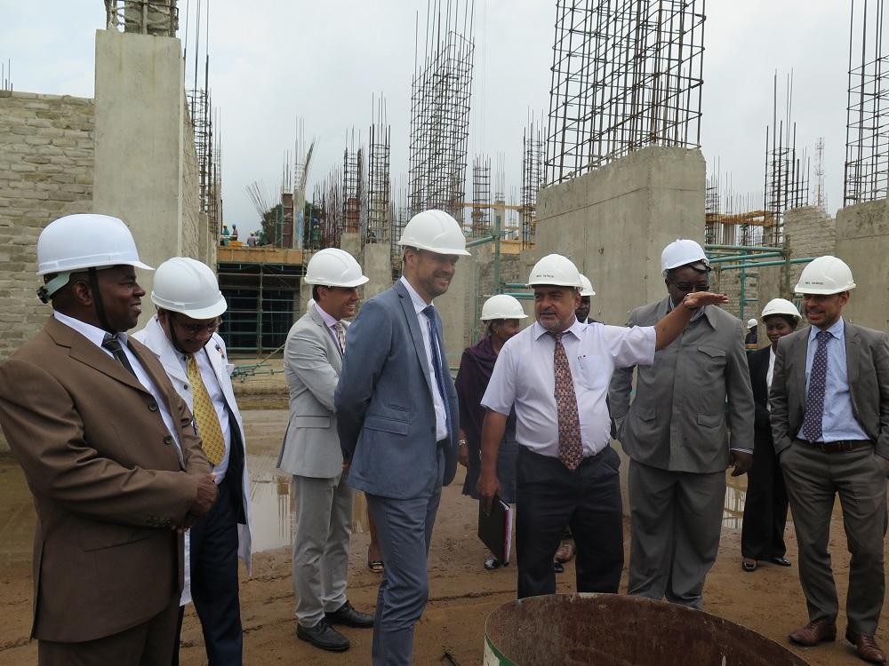
Photo taken during visit of the EU Delegation to the new MBS Laboratory Complex Construction Site
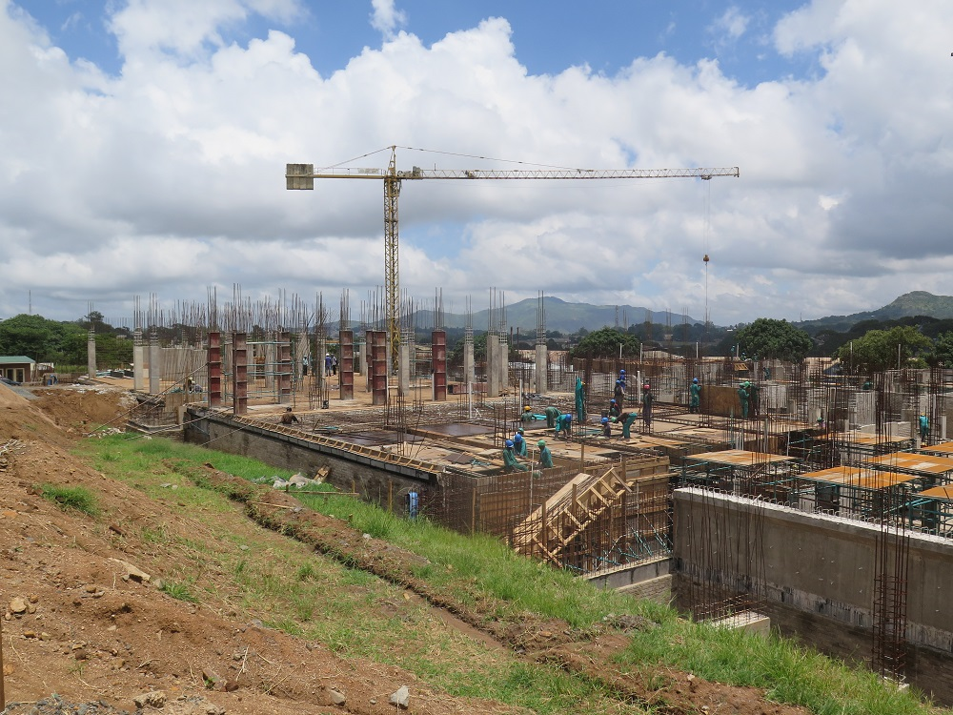
Photo showing the progress of the construction works of the new MBS Laboratory Complex
3.1b Develop within MBS an accredited product certification body  [MBS/UNIDO component] | - The Current implementation by MBS is in terms of the Pilot Phase for MBS to be accredited in ISO/IEC 17065 as a product certification body.  - Signed roadmap for accreditation of product certification body was shared with UNIDO, IEs and other concerned parties.  - The MBS is preparing for the industrial awareness on migration from current MBS certification scheme to IS 17065 requirements in readiness for the accreditation. This will be supported under output 6, activity 6.3.  - The MBS held Managements Systems review meeting on 21st February 2017 where system documentation, implementation and auditing were discussed at large in readiness for the accreditation. Gaps were identified and remedial actions were suggested  - The MBS and UNIDO discussed and agreed that SADCAS should be considered the accreditation body for the MBS because it is a local accreditation body in the SADC region and it is familiar with the challenges which laboratories within the region experience and so the MBS can be at an advantage if it is accredited by SADCAS.
3.2 Develop within MBS a management systems certification body for ISO 9001 and ISO 22000 / HACCP  [MBS/UNIDO component] | - Current implementation is in terms of the Pilot Phase for MBS to be accredited to ISO/IEC 17021 for ISO 9001 management system certification.  - The status on accreditation is the same as that of activity 3.1b.
3.3 Upgraded and accredited testing laboratories in MBS
[MBS/UNIDO component]
Trainings | - The trainings on general application of Chromatography Techniques, elements and Proficiency Testing (PT) schemes will be undertaken under activity 1.7.
Document Review of ISO 17025 system documents | - Mr. Reimond Willemse, International Laboratory Accreditation Expert, is still working closely with MBS in refining various laboratory documents.  - The MBS held Managements Systems review meeting on 21st February 2017 where system documentation, implementation and auditing were discussed at large in readiness for the accreditation. Gaps were identified and remedial actions were suggested.  - The MBS and UNIDO discussed and agreed that SADCAS should be considered the accreditation body for the MBS because it is a local accreditation body in the SADC region and it is familiar with the challenges which laboratories within the region experience and so the MBS can be at an advantage if it is accredited by SADCAS.  - UNIDO commenced communication on accreditation with SADCAS, in which the MBS is linked, and information on guidance on accreditation was obtained. This marks commencement of the process for the recruitment of the accreditation body for the actual accreditation process to be undertaken towards end of 2017.  - MBS is ready to submit accreditation application for microbiology and aflatoxin. Management reviews and internal audit to be done in parallel with accreditation application to SADCAS.
Procurement of laboratory equipment | - Technician from Anatech visited MBS on 8-10 March 2017 to repair Ion Chromatography. The damaged parts (1) ASSY, HP Eluent Generator (EG) DEGAS,5000PSI,CAP,ICS5, and (2) DX072079 Thermo Scientific Dionex Continuously Regenerated Cation Trap Column (CR-CTC) Capillary; were fixed. All the costs were covered by Anatech as the equipment was still on warranty.  - However, the technician also identified another problem with the Ion Chromatograph that the suppressor was also damaged and so it needs replacement. It was agreed that ANATECH would send the suppressor to MBS and MBS technicians would installed it as they were already trained. The suppressor arrived at the MBS on 31st March 2017.  - The procurement plan as approved by MBS management and was shared with UNIDO HQ and UNDP.  - Procurement of Universal Testing Machine (UTM) accessories and Ultra Pressure Liquid Chromatograph Mass Spectrometer Mass Spectrometer (UPLC-MS-MS) commenced. The MBS developed technical specifications for the equipment and were submitted to UNIDO. Completed UHPLC specifications and final bidding document were submitted to UNIDO HQ on 24/3/17.  - Preparation of technical specifications (TS) for X-Ray Florescence (XRF), Ion Coupled Plasma (ICP) and Oil Analyzer is in progress.  - The MBS is yet to submit TS for Laboratory Management System (LIMS) and MiniLab 153. It is the understanding that the LIMS be installed in the new Laboratory complex, but sample registration module will be initiated at current premises.  - A draft analysis of equipment planned for procured Vs actual equipment procured was developed to help analyze equipment that can be considered for phase 2.
3.4 Upgraded and Accredited Calibration Laboratories in MBS
-MBS metrology capacity | - The trainings are being undertaken under MATCB Project (a sister project to SQAM Project).
-Procurement of Equipment | - Daily operations at Metrology Services Departments are interrupted by intermittent power supply. UNIDO requested the MBS to submit the electrical load requirements for UNIDO to consider a generator set and/or/in-combination with solar power for supplying uninterrupted power supply to the calibration laboratories to ensure that environmental conditions for the labs are always maintained. The MBS engaged Sharma Electricals to do the analysis and a report is yet to be received. MATCB Project agreed to fund a generator set solution as appropriate. Preparation of the TORs for electric generator installation is underway.
3.5 Develop a training business unit.  [MBS/UNIDO component] | - The status on this activity has not changed.  - This was addressed in the functional review report and was incorporated in the MBS 2017-2021 Strategic Plan. Implementation is expected to commence when the Strategic Plan is out in 2017.  - There are no funds allocated to this activity. The MBS would use own resources.
3.6 Develop a business unit to manage a pool of Malawian auditors.  [MBS/UNIDO component] | - The status on this activity has not changed.  - The MBS is expected to identify the auditors for cohort 1 companies which are being offered technical assistance under output 6.  - The MBS is currently engaging local companies that have Quality Management Systems (QMS) and Food Safety Management Systems (FSMS) in order to use the systems as plat form for practicing auditing.  - There would be consideration for Auditor mentoring by IRCA registered auditors in Q3 and Q4 of 2017. This is dependent on practicing auditing by the MBS auditors as part of competence development initiative.
3.7 Collaboration with the Malawi Laboratory Association to strengthen the association as an integral part of the national quality infrastructure, notably in view of testing and calibration services  [MBS (UNDP)] | - This activity was concluded in 2014.

Output 4: Strengthened, Proactive And Responsive National Enquiry Points (NEP) To The Information And Notification Requirements Of WTO/TBT/SPS Agreements
ACTIVITY | STATUS
4.1 Identify, store, update, create and use the information on foreign TR, standards and conformity assessment dispositions of countries that import from Malawi  [MBS/UNIDO component] | - The remaining tasks under this activity will be undertaken together with activities 2.1 and 2.3.

Output 5: Sanitary and Phytosanitary (SPS) Infrastructure Improved and Mainstreamed into National Policies
ACTIVITY | STATUS
5.1 Review the national SPS infrastructure  [MBS/UNIDO component] | - This activity was concluded in 2016 and the closure of output 5 was approved by the SQAM Project Steering Committee during the 12th Steering Committee meeting.  - The works on the development for the food safety legislation were expected to continue outside the SQAM Project, however, it has been noted that there is no progress even though Food and Agriculture Organization (FAO) indicated that it had resources to complete the activity. There are plans of sourcing funds from other possible donors to support this. UNIDO would also explore other opportunities for the development of the Food Safety law.
5.2 Develop a road map to improve the Malawian SPS infrastructure.
[MBS/UNIDO component]

5.4 Review and upgrade the legislation for the SPS infrastructure
[MBS/UNIDO component]

Output 6: Capacity of Small and Medium sized Enterprises (SME), and particularly women and youth led enterprises, strengthened to comply with quality requirements
ACTIVITY | STATUS
6.1 Preparation of an overall training and technical assistance programme for SMEs, in particular female and youth headed SMEs | - This activity was concluded in 2015.
6.2 Technical assistance to 15 SMEs, in particular female and youth headed SMEs, to comply with HACCP / ISO 22000 Food safety management systems  [MBS/UNIDO component] | - Technical assistance to cohort 1 companies on ISO 22000 – Food Safety Management Systems is in progress.  - Ms. Anya Knotze, International Expert (IE) in food safety, did analysis on the 6 companies (Nali Limited, Linga Winery, Katete Daily, Project Peanut Butter, Ethco and Liquefied Carbon dioxide and Allied Gases). The following three companies were selected for certification in agreement with MBS management and CTA on 24 February 2017: Ethco, Linga Winery and Project Peanut Butter.  - IE prepared detailed workplan (together with MBS) with minimum workdays required for preparing the company for certification.  - The next mission is scheduled for 2nd to 13th April 2017 and 24th April to 4th May 2017.  - A report on this mission will be submitted to UNIDO and MBS.
6.3 Technical assistance to 10 SMEs, in particular female and youth headed SMEs, to comply with ISO 9001 Quality management systems.  [MBS/UNIDO component] | - Provision, for 4 companies, was made for 4 missions in 2017, 1 mission per quarter. MBS to ensure that in-country support is provided.  - Technical Assistance (TA) on ISO 9001; Quality Management Systems (QMS) at second group of Cohort 1 companies (Capital Oil Refinery Industries Ltd, Polyplast Ltd, Promat Ltd and Mzuzu Coffee Planters Cooperative Union) was undertaken from 13th February to 15th March 2017  - The IE, reported that the work on TA on ISO 9001 went well the report was being prepared by the expert.  - During the closing meeting that was held on 13th March 2017 it was agreed that:  - All subsequent missions should be aligned with the MBS approved roadmaps for accreditation. The MBS should share the roadmaps for accreditation with the IEs and the project team.  - There is need to look at the requirements of SADCAS in preparation for the accreditation of the MBS. SADCAS is better placed because it is a local accreditation body and so it is already aware of the limitations and the challenges within the SADC region.  - There is need to strengthen ISO 17021. The MBS can audit other companies e.g. Lafarge and Carlsberg in order to practice and identify the gaps of its auditors. This will help to build capacity and competence on MBS auditors. The MBS auditors should not go to the selected 4 companies due to conflict of interest but they can go to other companies with similar products.  - The MBS auditors can also visit neighboring certification bodies to learn how they undertake certain activities.
6.4 Other type of quality requirements in export markets. Technical assistance to SMEs.  Note:  Implemented in terms of a value chain approach | - This activity has been scheduled for 2017 Q2.  - Technical assistance and training on MS19 and MS21 to 60 managers from SMEs across the country i.e 20 from each region was planned for 2017. The participants are expected to be selected by the MBS and key stakeholders, including SMEDI, OVOP, SMEA and NASME.  - Industry migration to the new product certification scheme focusing on the bottled water sector under output 3, activity 3.1b will be supported under this activity.
6.5 Trainers-cum-counselors and auditors: Training in HACCP / ISO 22000 Food safety management systems. | - This activity was concluded in Q3 2016.
6.6 Training in ISO 9001 Quality management systems for trainers-cum-counsellors and auditors. | - This activity was concluded in Q3 2016.
6.7 Trainers-cum-counsellors: Training in "Initiating quality improvement in selected sectors" | - Implementation of this activity is foreseen for 2017 Q2.  - A study tour for selected MBS Officers and SME to a well-established enterprise which implements ISO 22000 in SADC region will be arranged.
6.8 Awareness seminars: ISO 14000 Environment management systems; GLOBALG.A.P. (Good Agricultural Practice) | - This activity was completed in November 2016. No further action required.
6.9 Trainers-cum-counsellors and auditors: Training in ISO/IEC 17025 | - This activity was concluded in Q3 2016.

Output 7: MBS Compliant with International Regulations established
ACTIVITY | STATUS
7.1 TA for the preparation of the organizational ad operational bylaws and business plan for the Malawian accreditation body.  [MBS/UNIDO component] | - This activity was concluded in 2015 Q2. No further action is required.

Output 8: Programme Management
ACTIVITY | STATUS
8.1 Operational Management Team
[UNDP/MBS/UNIDO component]
- Consumables- Office Supplies  - Vehicle costs (normal use and maintenance) | - All these are being supported for by the project.
8.2 Communications and Visibility
- Communication and Visibility (Plan), revision as needed | - 1000 calendars for 2017 were produced and distributed to various stakeholders.  - 3 big sign posts were erected at the new MBS Laboratory Complex, MBS Head Office and at the MBS Metrology Services Department.  - The EU delegation led by the EU Ambassador, His Excellency Marchel Germann, visited the MBS new laboratories construction site at Chichiri behind the Trade fair grounds in Blantyre on 28th February 2017. The Ministry of Industry, Trade and Tourism (MoITT) team also joined the EU delegation. They were welcomed to the site by the Mr. Davlin Chokazinga, Director General of Malawi Bureau Standards and Mr. Ouseph Padickakudi, Chief Technical Advisor for SQAM Project.  - More activities have been planned for Q2 as reflected in the attached Q2 Work Plan.
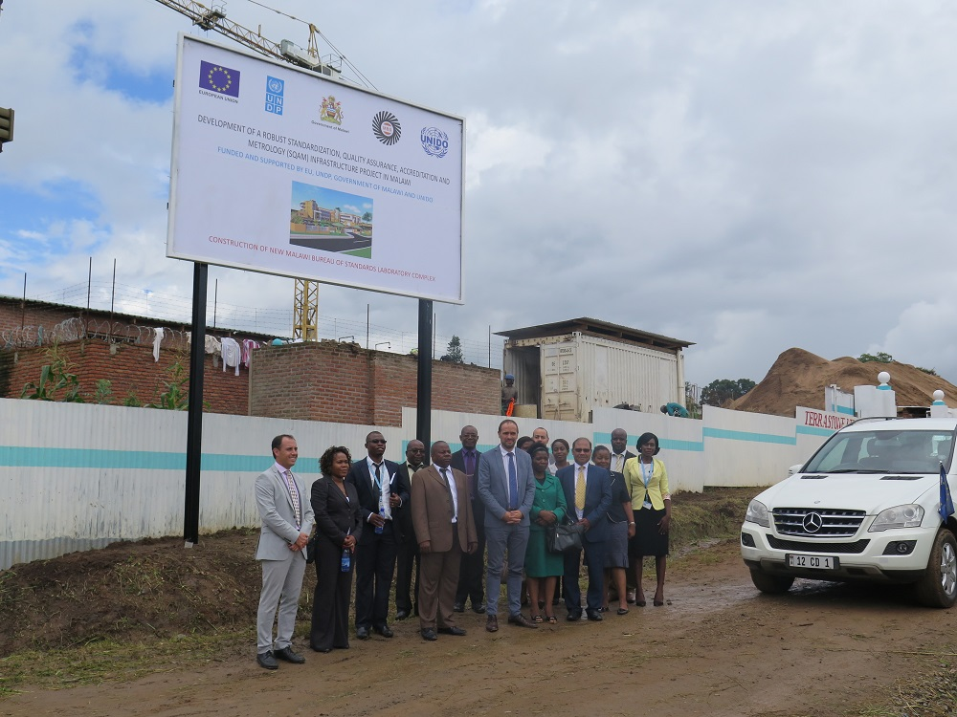
Photo taken during the EU visit to the New MBS Laboratory Construction Site on 28th February 2017

8.3 Programme Assurance, Coordination and Management
- Quarterly Steering Committee (SC) Meetings and Monthly Project Management Meetings  In accordance with project schedule | - The 29th monthly Project Management meeting was held Via Teleconference at UNDP in Lilongwe and MBS in Blantyre, on Thursday, 26th January 2017 at 03:00pm.  - The 30th monthly Project Management meeting was held Via Teleconference at UNDP in Lilongwe and MBS in Blantyre, on Thursday, 23rd February 2017 at 03:00pm.  - The 31st monthly Project Management meeting was postponed to April 2017.  - Regular operational management activities and other meetings.

Financial Status and Utilization
Table 1: Expenditure by Output (Quarter 4 – as of 31st December 2016)

UNDP TRAC

Activity | Fund Source | Budget  (MK) | Available Resources | Expenditure | Balance | Delivery Rate
Output 1:Strengthened capacity | Donor 00012 | 4,763,425.09 | 5,304,456.36 | 5,304,456.36 | 0.00 | 100.00%
Output 8: PROGRAMME MANAGEMENT
Output 8: PROGRAMME MANAGEMENT | Donor 00012 | 2,630,864.95 | 3,766,682.29 | 3,766,682.29 | 0.00 | 100.00%
TOTAL |  | 7,394,290.04 | 9,071,138.65 | 9,071,138.65 | 0.00 | 100.00%

EU

Activity | Fund Source | Budget  (MK) | Available Resources | Expenditure | Balance | Delivery Rate
Output 2:Technical Regulations | Donor 10159 | 199,584.00 | 199,584.00 | 199,584.00 | 0.00 | 100.00%
Output 3:Structurally Enhanced Capacity | Donor 10159 | 1,437,824.00 | 1,437,824.00 | 1,437,824.00 | 0.00 | 100.00%
Output 6:Capacity of SMEs | Donor 10159 | 4,976,000.01 | 4,976,000.01 | 4,976,000.01 | 0.00 | 100.00%
Output 8: PROGRAMME MANAGEMENT
Output 8: PROGRAMME MANAGEMENT | Donor 10159 | 2,142,987.72 | 2,142,987.72 | 2,142,987.72 | 0.00 | 100.00%
Bank Charges |  | 6613408.01 | 6613408.01 | 6613408.01 | 0 | 100.00%
TOTAL
GRAND TOTAL |  | 14,007,698.05 | 15,684,546.66 | 15,684,546.66 | 0.00 | 100%

*Data contained in this report is an extract from the Financial Reports submitted to UNDP on a monthly basis.
During quarter 4 the project was at 100% delivery rate.
Table 2: Cummulative Expenditure by Output (as of 31st December 2016)

Table 1: Expenditure by Output (Quarter 1 – as of 31st March 2017)

UNDP TRAC

Activity | Fund Source | Budget  (MK) | Available Resources | Expenditure | Balance | Delivery Rate
Output 1:Strengthened capacity | Donor 00012 | 5,400,000.00 | 5,400,000.00 | 484,200.00 | 4,915,800.00 | 8.97%
Output 8: PROGRAMME MANAGEMENT
Output 8: PROGRAMME MANAGEMENT | Donor 00012 | 2,192,680.00 | 2,192,680.00 | 151,907.07 | 2,040,772.93 | 6.93%
Bank Charges
TOTAL |  | 7,592,680.00 | 7,592,680.00 | 636,107.07 | 6,956,572.93 | 8.38%

EU

Activity | Fund Source | Budget  (MK) | Available Resources | Expenditure | Balance | Delivery Rate
Output 2:Technical Regulations | Donor 10159 | 7,000,000.00 | 7,000,000.00 | 0.00 | 7,000,000.00 | 0.00%
Output 6:Capacity of SMEs | Donor 10159 | 7,294,010.00 | 7,294,010.00 | 907,763.70 | 6,386,246.30 | 12.45%
Output 8: PROGRAMME MANAGEMENT
Output 8: PROGRAMME MANAGEMENT | Donor 10159 | 900,180.00 | 900,180.00 | 434,220.79 | 465,959.21 | 48.24%
TOTAL |  | 15,194,190.00 | 15,194,190.00 | 1,341,984.49 | 13,852,205.51 | 8.83%
GRAND TOTAL |  | 22,786,870.00 | 22,786,870.00 | 1,978,091.56 | 20,808,778.44 | 8.68%

*Data contained in this report is an extract from the Financial Reports submitted to UNDP on a monthly basis.

During quarter 1 the project was at 8.68% delivery rate.
Table 2: Expenditure by Output (Quarter 1 – as of 31st March 2017)

UNDP TRAC

Activity | Fund Source | Budget  (MK) | Available Resources | Expenditure | Balance | Delivery Rate
Output 1:Strengthened capacity | Donor 00012 | 5,400,000.00 | 5,400,000.00 | 484,200.00 | 4,915,800.00 | 8.97%
Output 8: PROGRAMME MANAGEMENT
Output 8: PROGRAMME MANAGEMENT | Donor 00012 | 2,192,680.00 | 2,192,680.00 | 151,907.07 | 2,040,772.93 | 6.93%
Bank Charges
TOTAL |  | 7,592,680.00 | 7,592,680.00 | 636,107.07 | 6,956,572.93 | 8.38%

EU

Activity | Fund Source | Budget  (MK) | Available Resources | Expenditure | Balance | Delivery Rate
Output 2:Technical Regulations | Donor 10159 | 7,000,000.00 | 7,000,000.00 | 0.00 | 7,000,000.00 | 0.00%
Output 6:Capacity of SMEs | Donor 10159 | 7,294,010.00 | 7,294,010.00 | 907,763.70 | 6,386,246.30 | 12.45%
Output 8: PROGRAMME MANAGEMENT
Output 8: PROGRAMME MANAGEMENT | Donor 10159 | 900,180.00 | 900,180.00 | 434,220.79 | 465,959.21 | 48.24%
TOTAL |  | 15,194,190.00 | 15,194,190.00 | 1,341,984.49 | 13,852,205.51 | 8.83%
GRAND TOTAL |  | 22,786,870.00 | 22,786,870.00 | 1,978,091.56 | 20,808,778.44 | 8.68%

*Data contained in this report is an extract from the Financial Reports submitted to UNDP on a monthly basis.

By end of quarter 1 the project was at 8.68% delivery rate.

Achievements
Q1 of 2017 has not achieved a lot as some of the activities just commenced and will be completed in Q2. Such activities include industrial awareness on the migration from current MBS certification scheme to ISO 17065 requirements in readiness for the accreditation. However, the SQAM Project has managed to achieve the following in 2017 Q1:
- The construction works of the new MBS Laboratory Complex is at 45%. It is in progress and on track. The payments are being made in accordance with the certificates of payment.
- Communication and visibility activities were undertaken such as 2017 calendars were produced and distributed to the various stakeholders; 3 big signposts were erected at the new MBS Laboratory Construction site, MBS Head Office and at the MBS Metrology Services Department.

- The MBS held Managements Systems review meeting where system documentation, implementation and auditing were discussed at large in readiness for the accreditation. Gaps were identified and remedial actions were suggested and are being implemented. Signed roadmap for accreditation of product certification body was shared with UNIDO, IEs and other concerned parties.

- The MBS and UNIDO discussed and agreed that SADCAS should be considered the accreditation body for the MBS because it is a local accreditation body in the SADC region and it is familiar with the challenges which laboratories within the region experience and so the MBS can be at an advantage if it is accredited by SADCAS. UNIDO commenced communication on accreditation with SADCAS, in which the MBS is linked, and information on guidance on accreditation was obtained. This marks commencement of the process for the recruitment of the accreditation body for the actual accreditation process to be undertaken towards end of 2017. The MBS is ready to submit accreditation application for microbiology and aflatoxin. Management reviews and internal audit to be done in parallel with accreditation application to SADCAS.

- The technical assistance to selected companies on Food Safety management Systems - ISO 22000 and Quality Management Systems – ISO 9001 is in progress.

Challenges and Lessons Learnt

The challenges which were experienced in 2017 Q1 include the following:
- The Government of Malawi allocated K1 billion only in the 2016/2017 National budget for the funding of the construction of the new MBS Laboratory Complex. This was raised to K1.4 billion at mid-year but it might not be enough to meet demands for payment as the fall due before the end of the financial year.

- Delay in procurement of goods and services. The MBS is bound by Public Procurement (ODPP) procedures and processes take long. One of the activities that were affected by ODPP procedures is the consultancy on Technical Regulations was advertised in the local newspaper in November 2016 but nobody applied for the consultancy. It took long to be placed in newspaper due to lengthy procedures and there are no applications received. The MBS discussed with the UNDP and agreed that the UNDP can come in to re-advertise the consultancy as their procurement procedures are short.

- The new regulations that are sent to Ministry of Industry, Trade and Tourism (MoITT) for notification to the World Trade Organization (WTO) take long to be notified. MoITT take long to notify WTO on new regulations. There is need to improve on communication between the MBS and MoITT to ensure that new regulations are notified by MoITT to WTO.

- Certain companies are unwilling to be certified by the MBS because it is not accredited. When the MBS wants to engage certain companies that are already certified by other certification bodies such as South African Bureau of Standards (SABS), to allow MBS auditors to observe how systems are being implemented as part of developing auditors’ competence, they express unwillingness to allow the MBS auditors to do so.

- The other challenge is that there is pressure on the anchors of the outs/ activities (MBS Directors) as implementation of the project brings extra work to their day-to-day work.

Conclusion and Recommendations
The MBS is pleased to have made progress on the activities which were planned for Q1 of 2017. There has been progress in a number of activities which were planned for implementation in Q1 such as; industrial awareness on the migration from current MBS certification scheme to ISO 17065 requirements in readiness for the accreditation, trainings on MS 19 and MS 21 are under preparation. The technical assistance to selected companies on Food Safety management Systems - ISO 22000 and Quality Management Systems – ISO 9001 is in progress.

The construction works of the new MBS Laboratory Complex is at 45%. It is in progress and on track. The payments are being made in accordance with the certificates of payment. The EU delegation led by the EU Ambassador, His Excellency Marchel Germann, visited the MBS new laboratories construction site at Chichiri behind the Trade Fair Grounds in Blantyre on 28th February 2017. The Ministry of Industry, Trade and Tourism (MoITT) team also joined the EU delegation. The visit indicated the commitment by the EU on their support to the SQAM Project.

Communication and visibility activities are being undertaken such as 2017 calendars which were produced and distributed to the various stakeholders; 3 big signposts were erected at the new MBS Laboratory Construction site, MBS Head Office and at the MBS Metrology Services Department.

SADCAS has been considered the accreditation body for the MBS because it is a local accreditation body in the SADC region and it is familiar with the challenges which laboratories within the region experience and so the MBS is at an. Communications with SADCAS on accreditation commenced and information on guidance on accreditation was obtained. This marks commencement of the process for the recruitment of the accreditation body for the actual accreditation process to be undertaken towards end of 2017. The MBS is ready to submit accreditation application for microbiology and aflatoxin. Management reviews and internal audit to be done in parallel with accreditation application to SADCAS.

Future Work Plan

The Q2 Work Plan has been developed to guide the anchors of the project activities on which activities have been planned for implementation in Q2. The Q2 Work-Plan for 2017 has been attached as annex 1 for reference.

Progress Report Approved and Submitted by Malawi Bureau of Standards

Signature:…………………………………………….. Date: …………………….
Willy Muyila,
National Project Coordinator

For: DIRECTOR GENERAL- MBS

Annexes:

Annex I – 2017 Q2 Work Plan
2017 SQAM Q2 WORK PLAN - Draft - (13 April 2017)
ACTIVITIES FOR NATIONAL IMPLEMENTATION ONLY
PLANNED ACTIVITIES | TIME FRAME |  |  | RESPONSIBLE PARTY | PLANNED BUDGET
 | Apr | May | Jun |  | Sources of Funds | Budget Description | Amount(MK)
OUTPUT 1: Strengthened capacity of the Malawi Bureau of Standards to deliver business services and to achieve financial sustainability
1.0 National Quality Policy
Tasks
Implementation of the NQS (MoIT)
Note: No funds allocated to this activity.
1.2 Review and set-up of organizational structures, service delivery procedures and knowledge management within MBS.  Tasks:  1. Implementation of recommendations and findings from functional review (MBS) Note: No funds allocated to this activity, MBS to use own resources. |  |  |  | MBS, MoIT, UNDP |  |  | -
2. Formulate new MBS strategic plan (2017 to 2021) as successor for 2011-2016) as implementation plan for recommendations provided through various IE’s on SQAM project through National Consultant, provision for:  -Validation workshop (MBS) Note: No funds were allocated to this activity in 2017 and so the validation workshop for the Strategic Plan will be undertaken together with the validation workshop for laboraratory Mapping |  |  |  | MBS, MoIT, UNDP
1.3 Market survey on the demand for testing and calibration in Malawi  Tasks:  Mapping of Malawi Laboratory landscape (MBS). Printing and dissemination of general profile of all testing and calibration laboratories in Malawi (Mapping of Malawi Laboratory landscape) (MBS) |  |  |  |  | UNDP | 75700 Training, Workshop and Conference | 3,600,000
 |  |  |  |  | UNDP | 74200-Printing | 1,800,000
1.5 Development of a "marketing unit" within MBS. |  |  |  | MBS |  |  | -
Task: MBS to develop a Marketing and Communication strategy, MBS to use own resources
1.7 Preparation and implementation of a "training plan" for MBS.
Tasks:
Suport in country logistics for Out-of-Country training in microbiology and chemistry at IFSTL in USA and FERA in UK. |  |  |  | MBS | EU | 75700-Training ,workshops & confer | -
Sub Total |  |  |  |  |  |  | 5,400,000
OUTPUT 2: Technical Regulations reviewed to promote efficient, effective and accountable delivery of information in accordance with SQAM legislation and regulations
2.1 Documentary and field survey of the Malawian situation with regards to technical regulations and enforcement. |  |  |  | MBS, MoITT | EU | 71300 Local consultant | 7,300,000
Task:Provision for local consultant to support MBS to undertake survey on all technical regulations |  |  |  | MBS, MoITT
2.3 Data gathering on Technical Regulation, analysis and consolidation;  and development of a database for Technical Regulation (To be done together with 2.1) (Consider also Act 4.1) |  |  |  | MBS, UNDP | EU | 72200 - Equipment | 7,300,000
Tasks:
1. Provision for IT equipment and information management system software (MBS) for the management of information on WTO notifications and their dissemination to stakeholders(together with 4.2)
2.4 Preparation of a strategy and a plan for the institutionalization of "Better Regulation" in Malawi Tasks: |  |  |  | MBS, UNDP, UNIDO | EU | 75700-Training ,workshops & confer | 2,000,000
1. Provision for support to prepare a strategy/ review of the SADC Regulatory Impact Assessment Framework and an implementation plan and actions for the institutionalization of “Better Regulation” related to the strategy (e.g. Regulators Committee Meetings/ workshops) (MBS) (This activity has been carried over from Q1) |  |  |  | MBS, UNDP, UNIDO | EU | 71600-Travel | 1,650,000
2. Provision for support to the implementation actions related to the strategy (MBS)
3. Commence TR review through the Food Sector Risk Advisory Group as a pilot phase (MBS).
4. Support in country logistics for study tour of MBS staff to established NEP (MBS/UNIDO) - Uganda National Bureau of Standards is being considered.
Sub Total |  |  |  |  |  |  | 18,250,000
OUTPUT 3: Structurally enhanced capacity of the Malawi Bureau of Standards for conformity assessment services
3.1b Develop within MBS an accredited product certification body. |  |  |  | MBS | EU
Task: |  |  |  | MBS | EU
1. MBS to implement auditors’ competence development programme for auditors to gain experience (to be supported under activity 3.6). 2. Select 30 companies from the existing MBS Product (Permit) Certification Scheme for introduction of the Product Certification System based on ISO 17065 requirements and implement the Product Certification System based on ISO 17065 on selected companies(MBS). Note: This will be supported under activity 6.4 |  |  |  | MBS
3.2 Develop within MBS a management systems certification body for: - ISO 9001 (quality management systems); - ISO14001 (environmental management systems); ISO 22000 (food safety management systems) |  |  |  |  | EU
Task:
2. Implementation of ISO 17021 system in preparation for accreditation application:
Note: at least 2 QMS to be certified before accreditation and at least 2 QMS to be ready for assessors’ witnessing
3. ISO 9001 and ISO 19011 trainings for members of the certification, impartiality and appeals resolution committees.
3.3 Upgraded and accredited testing laboratories in MBS. Tasks: |  |  |  | MBS, UNDP | EU |  | -
1. Advance in accordance with procurement plan (MBS/UNIDO)
2. Implementation of Management System for the application of the ISO/IEC 17025. (MBS)
3. Initiate quality control/ compliance activities to address gaps:
- Calibration of equipment
- Reference materials
- Environmental conditions
- Proficiency testing (MBS at this time participating in PT schemes for Petrochemicals, Tensille/ compression stress etc. in support of pilot phase scope) (MBS)
Note: Participation in PT schemes can be supported under activity 1.7 (funds permitting)
3.4 Upgraded and accredited calibration laboratories in MBS. |  |  |  | MBS,UNIDO | EU |  | -
Task: |  |  |  | MBS,UNIDO | EU
1. Advance in accordance with procurement plan (MBS/UNIDO) |  |  |  | MBS,UNIDO | EU
3.5 Enhance the MBS training business unit mainly for management systems standards, complying with ISO 29990 .
Tasks:
2. Establish training unit with staff in accordance with the Functional Review actions (MBS)
3.6 Establish a pool of Malawian Auditors
Tasks:
1. MBS to identify the auditor for each Cohort I company (This activity has been rolled over from Q1)
Sub Total |  |  |  |  |  |  | -
OUTPUT 4: Strengthened, proactive and responsive National Enquiry Points (NEP) to the information and notification requirements of WTO/TBT/SPS agreements
OUTPUT 5: Sanitary and Phytosanitary (SPS) Infrastructure Improved and Mainstreamed into National Polices
OUTPUT 6: Capacity of Small and Medium sized Enterprises (SME), and particularly women and youth led enterprises, strengthened to comply with quality requirements
6.2 Technical assistance to 15 SMEs, in particular female and youth headed SMEs, to comply with HACCP / ISO 22000 Food safety management systems. |  |  |  | MBS, UNIDO, UNDP | EU | 71600-Travel | 1,000,000
Tasks: |  |  |  | MBS, UNIDO, UNDP | EU
1. Suport in country logistics on Technical Assistance to companies through IE in support of implementation of ISO 22000 systems on Cohort 1 SMEs (UNIDO) |  |  |  | MBS, UNIDO, UNDP | EU
6.3 Technical assistance to SMEs, in particular female and youth headed SMEs, to comply with ISO 9001 Quality management systems. |  |  |  | MBS, UNIDO | EU | 71600-Travel | 1,000,000
Tasks: |  |  |  | MBS, UNIDO | EU
1. Suport in country logistics on Technical Assistance to companies through IE in support of implementation of ISO 9001systems on Cohort 1 SMEs (UNIDO) |  |  |  | MBS, UNIDO | EU
6.4 Other type of quality requirements in export markets. Technical assistance to SMEs. |  |  |  | MBS, UNIDO | EU | 75700-Training ,workshops & confer | 61,000,000
Tasks: |  |  |  |  |  | 74200-Audiovisual & Print Prod Costs | 600,000
1. 60 managers from SMEs across the country i.e 20 from each region to be selected by the MBS and key stakeholders, including MITC, SMEDI, MCCCI, SMEA and NASME, for MS 21 and MS 19 trainings. |  |  |  | MBS, UNIDO | EU | 72300-Fuel | 2,000
6.7 Trainers-cum-counsellors: Training in "Initiating quality improvement in selected sectors" |  |  |  | MBS | EU | 75700-Trainings, workshops and conference | 7,300,000
1. Study tour for selected SMEs and MBS managers to FSMS/HACCP implementing enterprises in the SADC region
Noted:
This activity is linked to activity 6.4.
Sub Total |  |  |  |  |  |  | 72,033,510
OUTPUT 7: MBS compliant with International Regulations established
OUTPUT 8: PROGRAMME MANAGEMENT
8.1 Operational Management Team |  |  |  | MBS, UNDP | EU | 74500 - Miscellaneous | 45,000
8.1 Operational Management Team |  |  |  | MBS, UNDP | EU | 72500 - Supplies | 561,000
8.1 Operational Management Team |  |  |  | MBS, UNDP | EU | 73400 - Rental & Maintenance | 294,180
8.2 Communications and Visibility |  |  |  | MBS/UNDP | EU
1. Production of Quarterly SQAM News letters |  |  |  | MBS/UNDP | EU | 74200 - Communications and Audiovisual | 11,000,000
2. Industrial awareness seminas on new equipment of MBS and MBS's current capacity in all 3 regions (Blantyre, Lilongwe and Mzuzu) |  |  |  | MBS/UNDP | EU | 75700 - Training, Workshops and Confer | 4,500,000
3. Production of 3,000 Z fold project brochures
4. Production of 3,000 Z fold brochures for the Testing Services Department of the MBS
5. Center-spread Newspaper press release on the MBS new eqipment and current capacity for the MBS.
6. Media Tour and seminar for the new MBS Laboratory Complex
6. Press release, radio and TV jingles and airing.
7. Support the MBS on World Metrology Day 2017 (WMD 2017) on 20th May 2017 with various activities including awareness and publicity events.
8.3 Programme Assurance, Coordination and Management |  |  |  | MBS, UNDP | UNDP | 72300 - Fuel | 386,400
8.3 Programme Assurance, Coordination and Management |  |  |  | MBS, UNDP | UNDP | 72400 - Communication & Audio Visual | 135,780
8.3 Programme Assurance, Coordination and Management |  |  |  | MBS, UNDP | UNDP | 72500 - Supplies | 60,500
8.3 Programme Assurance, Coordination and Management |  |  |  | MBS, UNDP | UNDP | 75700-Training ,workshops & confer | 600,000
8.3 Programme Assurance, Coordination and Management |  |  |  | MBS, UNDP | UNDP | 72100 Contractual Services | 240,000
Sub Total |  |  |  |  |  |  | 17,822,860
Grand Total |  |  |  |  |  |  | 113,506,370

Annex II Project Monitoring Tool
CP Component _________________
Implementing Partner: Malawi Bureau of Standards (MBS)
With cumulative achievements to date
EXPECTED CP OUTPUTS AND INDICATORS INCLUDING ANNUAL TARGETS | PLANNED ACTIVITIES  List all the activities including monitoring and evaluation activities to be undertaken during the year towards stated CP outputs | EXPENDITURES  List actual expenditures against activities completed | RESULTS OF ACTIVITIES  For each activity, state the results of the activity | PROGRESS TOWARDS ACHIEVING CP OUTPUTS  Using data on annual indicator targets, state progress towards achieving the CP outputs. Where relevant, comment on factors that facilitated and/or constrained achievement of results including:  - Whether risks and assumptions as identified in the CP M&E Framework materialized or whether new risks emerged  - Internal factors such as timing of inputs and activities, quality of products and services, coordination and/or other management issues
Output 1: Strengthened capacity of the Malawi Bureau of Standards to deliver business services and to achieve financial sustainability
1.1 Number of National Quality Policies (NQP), fast-tracked and approved by Cabinet.  Baseline: 1 draft  Target: 1 approved National Quality Policy.  1.2 Level of increased organizational effectiveness of MBS  Baseline: to be determined at project inception  Target: MBS revised structure and procedures created and operationalized.  1.3 Percentage increment of business services per year provided to Malawian organisations, both public and private,  Baseline: 100 Standards developed, 142 Certified products and Services, 3046 Samples Tested, 800 Verification Audits -Metrology Services)  Target: 30 % increase in services/per year  Note: MBS position is that this is achievable. MBS Strategic Plan provides for similar indicators.  1.4 Percentage increase in revenue growth per year  Baseline: 20%/year  Target: 30%/year  Note: Current growth is 30% (DFA), MBS position is that this is achievable. MBS Strategic Plan provides for similar indicators. | - Support to National Quality Policy implementation  - Support to the Ministerial task team in the implementation of the NQS. (MoIT). |  |  | - National Quality Policy (NQP) was developed, launched, printed and distributed.  - National Quality Strategy (NQS) was launched. NQS printed and distributed.  - National Quality Strategy Coordination Committee (NQSCC) was established.
 | - Review and set-up of organisational structures,  - Review quantitative data (e.g. from annual reports) and analysis as basis for indicators (MBS)  - Confirm/adjust the baseline for this indicator (MBS)  - Implementation of recommendations and findings from functional review (MBS)  - Formulate new MBS strategic plan (2016 to 2020) as successor for 2011-2016) as implementation plan for recommendations provided through various IE’s on SQAM project through National Consultant, provision for: |  |  | - Baseline indicators reviewed and confirmed.  - Functional Review and Job Evaluation was done. Now under implementation. An implementation team was set up; an implementation plan was developed, staff and salary placement were done.  - Procurement and installation of the Enterprise Resource Planning (ERP) system was done.  - The MBS 2017 – 2021 Strategic Plan was developed.
 | - Market survey on the demand for testing and calibration in Malawi  - Mapping of Malawi Laboratory landscape (MBS) |  |  | - Draft report available
 | - Preparation of a business plan and monitoring system for MBS.  - Implementation by MBS of recommendations as outlined in the 2015 Visser report through incorporation of these in MBS strategic plan 2016-2020 (MBS) |  |  | - Addressed in 2017-2021 MBS Strategic Plan
 | - Development of a "marketing unit" within MBS.  - MBS to adopt marketing strategy and policy, by Q2 (MBS)  - Marketing unit established and marketing materials regularly produced, by Q4 (MBS) |  |  | - Addressed in 2017-2021 MBS Strategic Plan.
 | - Preparation and implementation of a "training plan" for MBS.  - Out-of-country training in food safety testing subject to procurement waiver for IFSTL, USA. |  |  | - Four Out-of-Country training for Testing Services Department (TSD) in “Methods of Determination for Pesticide Residues”; “Microbiological Methods for Meat and Poultry” and “Methods of Determination for Drug Residues in Fish, Meat, and Poultry” were successfully undertaken at International Food Safety Training laboratory (IFSTL) – University of Maryland in USA.
Output 2: Technical Regulations reviewed to promote efficient, effective and accountable delivery of information in accordance with SQAM legislation and regulations

- Number of Technical Regulations reviewed and aligned to International regulations and legislation  Baseline: 8;  Target: 12  - Number of organizations promoting clear technical regulations  Baseline: 8;  Target: 12 | - Documentary and field survey of the Malawian situation with regards to technical regulations and enforcement.  - Provision for local consultant to support (MBS) |  |  | - ToRs were placed in the newspaper. Work to continue in 2017 Q1.
 | 2.2 Awareness campaigns and training on "Better regulation." |  |  | - This activity was completed in 2015
 | - Data gathering on Technical Regulation, analysis and consolidation; and development of a database for Technical Regulation  - 1. Local consultants to support specifically the aspect of the data base and information management system development where such database includes provisions related to the SPS/TBT enquiry points and notifications (ref. Output 4) (MBS)  - 2. Provision for IT equipment (MBS) |  |  | - The data base for Technical Regulations is already available on the Malawi Trade Portal.  - IT equipment to be considered in 2017.
 | - Preparation of a strategy and a plan for the institutionalization of "Better Regulation" in Malawi  - Provision for support to prepare a strategy/ review of the SADC Regulatory Impact Assessment Framework and an implementation plan and actions for the institutionalization of “Better Regulation” related to the strategy (e.g. Regulators Committee Meetings/ workshops) (MBS)  - Provision for support to the implementation actions related to the strategy (MBS)  - Commence TR review through the Food Sector Risk Advisory Group as a pilot phase (MBS).  - Support Malawi delegation in participation of international TBT/SPS committees (UNIDO)  - Study tour to established NEP (MBS/UNIDO) |  |  | - The participation of the MBS in Sanitary and Phytosanitary (SPS) meeting from 24th to 27th October 2016 and the Technical Barriers to Trade (TBT) meeting from 7th to 11th November 2016 in Geneva Switzerland.  - The Task Team agreed in principle to use the SADC approach and to beef it up with the IE and WTO approaches.  - Study tour to an established NEP was postponed to 2017 Q1.
Output 3: Structurally enhanced capacity of the Malawi Bureau of Standards for conformity assessment services

- Number of Metrology Institutes constructed  Baseline: 0;  Target:1  - Percentage increase in demand and supply of MBS business services (standards, training services, testing and calibration.  Baseline: 21%/year;  Target: 30% /year  - Number of accreditations granted by an accreditation body full member of IAF.  Baseline: 0;  Target: 1  - Number of MBS management systems certification body accreditations granted by an accreditation body full member of IAF for the international standards; ISO 9001 ISO 22000 and HACCP.  Note: HACCP certification is not a recognized accreditation  Baseline: 0;  Target: 1  - Number of MBS testing laboratories accreditation granted by an accreditation body full member of ILAC for the international standards.  Baseline: 0;  Target: 2 | - (a) Construction of the Metrology building  - Scope of work: new MBS complex at Chichiri. |  |  | - The contract with Terrastone, the Contractor of the new MBS Laboratory complex, was signed on 25th April 2016.  - 39% of the construction works of the new MBS Laboratory Complex was completed.  - 7 certificate of payment have been honored in full by the Malawi Government.
 | - Develop within MBS an accredited product certification body  - 1Redress gaps established during pre-assessment of ISO 17065 management system by IE (MBS).  - 2. Select 30 companies from the existing MBS Product (Permit) Certification Scheme for introduction of the Product Certification System based on ISO 17065 requirements and implement the Product Certification System based on ISO 17065 on selected companies(MBS) |  |  | - The development of ISO 17065 and ISO 17021 system documentation was completed.  - The training on Migration of ISO 9001:2008 to ISO 9001:2015, the training on ISO 19011:2011 Guidelines on Auditing Management (Internal Auditor Training) and Lead Auditor training on ISO 22000 have been completed  - Selection of companies to be done in 2017 Q2.
 | - Upgraded and accredited testing laboratories in MBS.  - Prepare final cycle procurement plan (MBS/UNIDO)  - Management system for the application the ISO/IEC 17025. Document review (MBS)  - IE to do pre-assessment (UNIDO)  - Initiate quality control/ compliance activities to address gaps:  - Calibration of equipment  - Reference materials  - Environmental conditions  - Proficiency testing (MBS at this time participating in PT schemes in support of pilot phase scope) (MBS) |  |  | - The pre-assessment of ISO 17025 system documentation at the MBS Testing Services Department (TSD) was conducted. The findings indicated that 95% of the system documents was completed.  - Several equipment were procured, installed and are operational e.g.  - High Performance Liquid Chromatography (HPLC),  - Atmospheric Distillation Analyzer, Aflatoxin Reactor and Reference materials,  - Ion Chromatograph,  - 1,500 KN Universal Testing Machine (UTM),  - Weighbridge Testing Truck with forklift and weights (1000kg x30, 20kg x10, 2kg x10 and 1kg x10),  - 2,500 tone Workshop crane,  - 2,500 liters Proving Tank,  - Master Flow Meter,  - High sensitive Mass Comparators with mass pieces and data loggers,  - Participation in PT Schemes will be considered in 2017.  - Some methods are ready for accreditation e.g. Aflatoxin.
 | - Upgraded and accredited calibration laboratories in MBS.  - Prepare final cycle procurement plan (MBS/UNIDO)  - Commissioning of mobile equipment procured, including verification processes, field tests, etc. |  |  | - Mass equipment was procured and delivered at MBS Metrology Services Department. The equipment is operational. Mass Equipment include: Manual Mass Comparators and mass pieces).  - Commissioning of mobile equipment was done; ownership of equipment was transferred to MBS.
 | - Enhance the MBS training business unit mainly for management systems standards, complying with ISO 29990.
 | - Establish a pool of Malawian Auditors.
 | - Collaboration with the Laboratory Association of Malawi (LAM) to strengthen the association as an integral part of the national quality infrastructure, notably in view of testing and calibration services. |  |  | - Collaboration with LAM is there. This activity was concluded in 2014.
Output 4: Strengthened, proactive and responsive National Enquiry Points (NEP) to the information and notification requirements of WTO/TBT/SPS agreements
4.1 Number of databases established and made available to the general public that provide all Malawi technical regulations (TR), drafted and approved national standards.  Baseline: 0;  Target: 1  4.2 Number of TR not notified during the drafting stage.  Baseline: n/a (to be determined during the inception phase of the project).  Target: Zero TR that are not notified  4.3 Number of publicly accessible services for exporting companies on foreign TR, standards and conformity assessment dispositions of countries that import from Malawi.  Baseline: 0;  Target: 1 | 4.1 Identify and create a database of Malawi technical regulations (TR), drafted and approved national standards |  |  | - Remaining tasks are being done together with activities 2.1 and 2.3.
 | 4.2 Identify, store, update, create and use the information on foreign TR, standards and conformity assessment dispositions of countries that import from Malawi

Output 5: Sanitary and Phytosanitary (SPS) infrastructure improved and mainstreamed into National polices
- Number of SPS infrastructure action plans approved and implemented  Baseline: 0; Target: 1  - Number of Reports on the review and upgrade of SPS legislation in Malawi discussed and approved by stakeholders.  Baseline: 0; Target: 1 | - Review the national SPS infrastructure  (focus on food safety, MBS |  |  | - This was concluded with a report which was developed by Food and Agriculture Organization (FAO) on the Food Safety Legislation. The report was accepted without any amendments.
  - Develop a road map to improve the Malawian SPS infrastructure.
- Continuation of FAO actions to develop the draft food safety law. (UNIDO)
  - Review and recommendations for the upgrade of legislation for the SPS infrastructure
- Continuation of FAO actions to develop the draft food safety law. (UNIDO)
Output 6: Capacity of Small and Medium sized Enterprises (SME), and particularly women and youth led enterprises, strengthened to comply with quality requirements
6.1 Number of HACCP / ISO 22000 Food safety management systems in place in a selected number of SMEs.  Baseline: 0;  Target: 15  - Number of ISO 9001 Quality management systems in place in a selected number of SMEs.  Baseline: 0;  Target: 10  - Number of SME able to comply with specific quality requirements in export markets.  Baseline: 0;  Target: 10  - Number of Trainers-cum-counsellors and auditors: training in HACCP / ISO 22000 Food safety management systems and approved as trainers and auditors.  Baseline: 0;  Target: 18 | 6.1 Preparation of an overall training and technical assistance programme for SMEs, in particular female and youth headed SMEs |  |  | - This was concluded in 2015
 | - Technical assistance to SMEs, in particular female and youth headed SMEs, to comply with HACCP / ISO 22000 Food safety management  - Technical Assistance to companies through IE in support of implementation of ISO 22000 systems on Cohort 1 SMEs (UNIDO) |  |  | - In progress, to continue in 2017
 | - Technical assistance to SMEs, in particular female and youth headed SMEs, to comply with ISO 9001 Quality management systems.  - Technical Assistance to companies through IE in support of implementation of ISO 9001systems on Cohort 1 SMEs (UNIDO) |  |  | - In progress, to continue in 2017.
 | 6.4 Other type of quality requirements in export markets. Technical assistance to SMEs.
 | 6.5 Trainers-cum-counsellors and auditors: Training in HACCP / ISO 22000 Food safety management systems. |  |  | - Training of Trainers and Auditors cum-Counsellors in ISO 22000 was completed in August 2016. What remains is to find out whether the objectives of the project on this activity were achieved.
 | 6.6 Training in ISO 9001 Quality management systems for trainers-cum-counsellors and auditors. |  |  | - Training of Trainers and Auditors cum-Counsellors in ISO 9001 was completed in August 2016. What remains is to find out whether the objectives of the project on this activity were achieved.
 | 6.7 Trainers-cum-counsellors: Training in "Initiating quality improvement in selected sectors"
 | 6.8 Awareness seminars: ISO 14000 Environment management systems; GLOBALG.A.P. (Good Agricultural Practice)  - Seminar during World Standards Day (Oct 2016)  - Seminars in Blantyre/Lilongwe/Mzuzu (MBS/UNIDO) |  |  | - Global Gap seminars/ workshops were conducted. This activity was concluded.
 | 6.9 Trainers-cum-counsellors and auditors: Training in ISO/IEC 17025 |  |  | - Training of Trainers and Auditors cum-Counsellors ISO17025 was completed in August 2016. What remains is to find out whether the objectives of the project on this activity were achieved.

